**University of Petroleum and Energy Studies**

School of Computer Science

Department of Cybernetics



**Graphics & Animation Tools**

**LAB FILE**

**(Session: 2020-2021)**

Course: B. Tech with Specialization in Open Source and Open Standards

Batch: 2017-2021

Semester: VIIth

**Submitted By: -**

Nikhil Mishra

Roll No: R100217043

SAP ID: 500062584

**Submitted To: -**

Dr. Durgansh Sharma Assistant Professor

Department of Cybernetics

**Experiment – 2** Design a LOGO/ Picture using GIMP

Step: 1 Open GIMP, go to file->new file-> choose 1080x1080 size screen with white as background.

Step: 2 Step: 2 Open GIMP, and go to file->Open As Layers-> And open the picture/drawing as a layer.

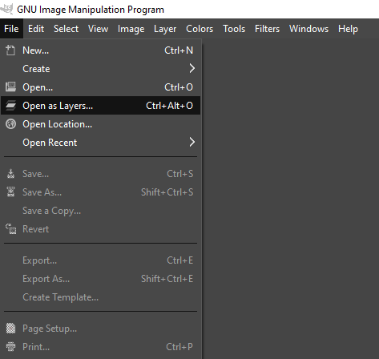

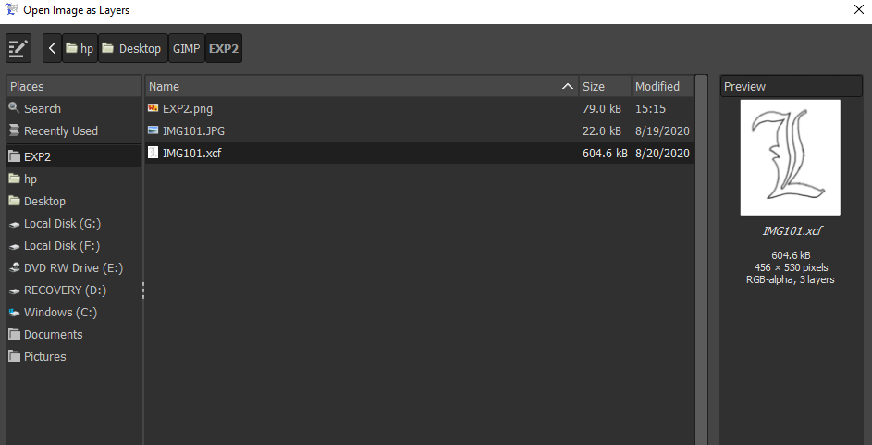

Step: 3 Now choose free select tool from toolbar, and start selecting the border/boundaries of the picture.

Step: 4 After selecting all the boundaries, connect the last point with the first one and cur that portion from that image using CTRL+X.

Step: 5 Paste this image on the white background layer from the Layers column.

Step: 6 Select Paintbrush tool from the toolbar and a colour from colour palette, I chose black.

Step: 7 Start drawing the boundaries of the letter with steady hand, so that you could get a layer like this.

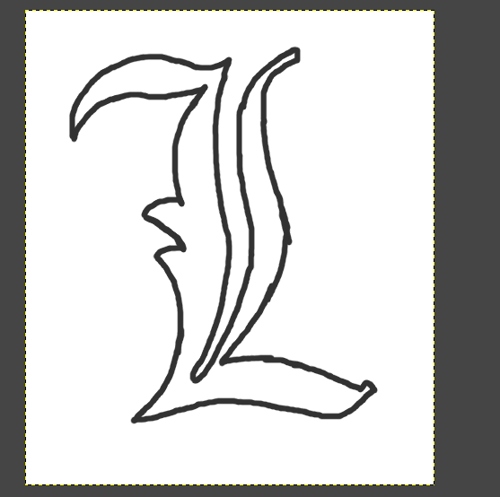

Step: 8 Now select the Bucket fill tool from toolbar and modify it’s setting according to your creativity.

Step: 9 I used Fill Type-> Pattern fill (blue web pattern) and Affected Area-> Fill by line art detection.

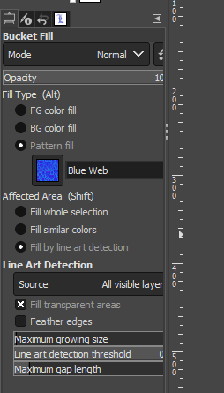

Step: 10 Start filling your image with chosen pattern by tapping inside the boundaries.

Step: 11 Save the output and export it as png.

**OUTPUT:**

